**Blocka Cash App Review**

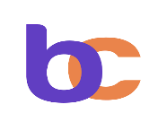

**Author: Precious Iyekeoretin**

**Introduction**

**Blocka Cash is a mobile app that provides quick and easy access to loans. The app is designed to make the loan application process as simple and convenient as possible, eliminating the need for long queues, paperwork, and waiting times. To get started with Blocka Cash, users need to sign up and set up an account, apply for a loan in seconds, and receive the loan instantly and directly into their wallet. The app offers micro-credit and makes provision for short-term personal loans, with loan amounts ranging from N5,000 to N50,000 depending on the user's credit score. The repayment period is usually monthly, with interest rates ranging from 3% to 10% per month, which equates to an Annual Percentage Rate (APR) of 36% to 120%. When assessing a user's eligibility for a loan, the app takes into account several factors such as past loan performance and credit score. The app is powered by James Crown Credit Limited and is licensed as a Money Lender by the Ogun State Government of Nigeria. Users can contact the company with feedback, tips, questions, and concerns.**

**Apple Store Rating**

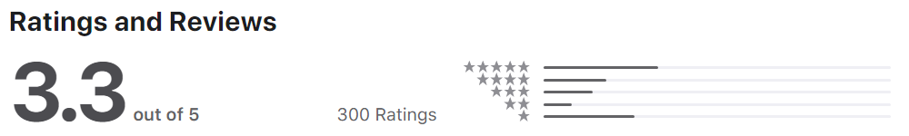

**Google Play store Rating**

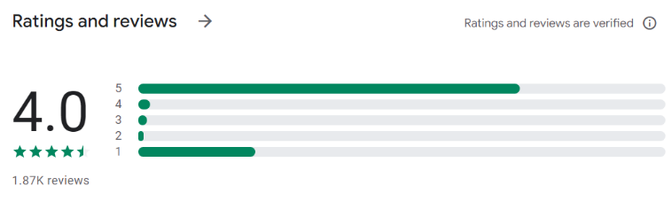

**Word Cloud for Blocka Cash.**

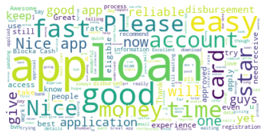

**Irorun App Review**

**Introduction**

**Irorun is a mobile app that offers fast and easy access to loans. The app's name, "Irorun," means peace of mind in the Yoruba language, and it aims to provide users with a convenient and reliable way to fix their spending gaps. To get started with Irorun, users need to create an account, apply for a loan in seconds, and receive the loan straight into their wallet. They also have the option to increase their loan limit every time they repay a loan. The app offers microloans with amounts ranging from N5,000 to N50,000. The repayment terms range from 60 days to 180 days, with interest rates ranging from 3% to 5% per month, which equates to a typical APR of 36%. The app usually does not require collateral or guarantors, but for loans beyond certain amounts, additional documentation may be required. The app assesses a user's eligibility for a loan by looking at several signals such as credit score and past loan performance. The company welcomes feedback and tips to make their services better and can be contacted at**[**support@irorun.com**](mailto:support@irorun.com)

**Apple Store Rating**

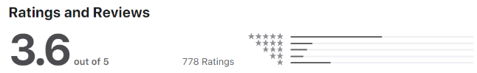

**Google Play store Rating**

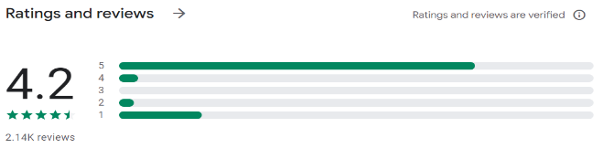

**Word Cloud for Irorun.**

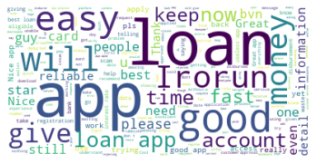

**COMPARISON AND CONCLUSION**

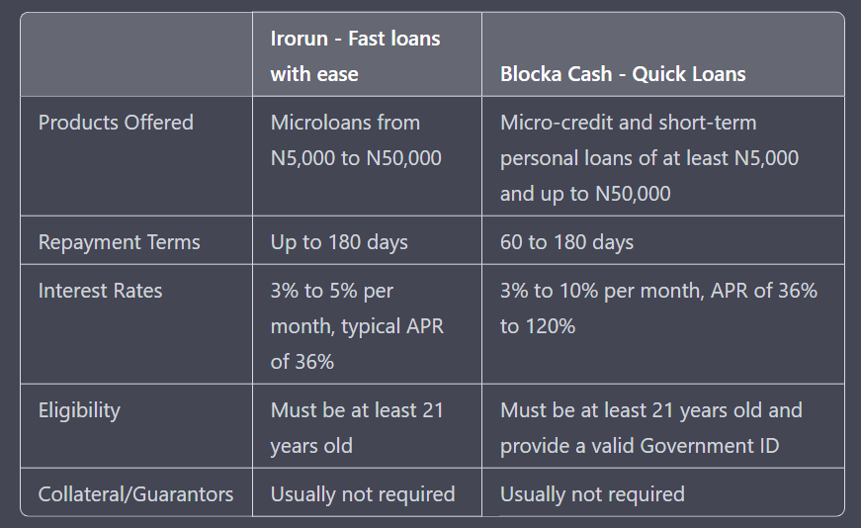From the table above, we can see that Irorun and Blocka Cash both offer microloans and short-term personal loans, with similar repayment terms and interest rates. However, Irorun has a lower interest rate with a typical APR of 36% compared to Blocka Cash's APR of 36% to 120%. Both lenders have similar requirements for eligibility and do not typically require collateral or guarantors.

In terms of user reviews, Irorun has a higher rating of 4.2 stars with 2.14K reviews, while Blocka Cash has a rating of 4.0 stars with 1.87K reviews. Both apps have received positive feedback for their easy-to-use interfaces and fast disbursement of loans.

In conclusion, Irorun and Blocka Cash are both reliable options for accessing loans quickly and easily. Irorun has a lower interest rate, which may make it a more cost-effective option for some users. However, Blocka Cash may be a better option for users who require a higher loan limit. Both lenders could improve by providing more transparent information about their fees and interest rates, as well as more detailed instructions for the loan application process.

Source <https://apps.apple.com/ng/app/blocka-cash/id1548212165> <https://apps.apple.com/ng/app/irorun-fast-loans-with-ease/id1511430092> <https://play.google.com/store/apps/details?id=com.irorun&gl=BM> <https://play.google.com/store/apps/details?id=cash.blocka&gl=ng>